ClimaGuard AI – Climate-Based Disease Outbreak Prediction

Summary
ClimaGuard AI gives Tamil Nadu's district health officers a 7–14 day outlook of where dengue and influenza risk is rising, explains why, and turns it into age-specific actions for field teams before cases peak.
Existing Indian warning systems stop at a risk label. ClimaGuard adds a per-district explanation, what-if scenarios for rainfall and humidity, and vulnerability-aware guidance, plus a feedback loop that shows its own track record.
The prototype trains on real public data (HMIS dengue reports and Open-Meteo weather) and spotlights five contrasting districts: Chennai, Coimbatore, Krishnagiri, Madurai and The Nilgiris. Every output is a population-level risk estimate, never an individual medical diagnosis.

1. Problem Statement Analysis
Public health teams in Tamil Nadu act after dengue cases rise, even though the weather that drives mosquito breeding is visible weeks earlier. That gap between climate signal and case surge is the lead time ClimaGuard captures.

Why this matters in Tamil Nadu
- Highest burden in India. Tamil Nadu reported the most dengue cases in the country in January–June 2026: 7,511 (The South First). It also topped the country in 2025 with 20,866 cases from January to November (DT Next).
- A different monsoon. Most rain arrives with the northeast monsoon from October, when the state asks district officers to step up mosquito surveillance (The News Minute). A model driven by weather rather than a fixed calendar fits this pattern.
- Response is reactive today. In October 2025 the state declared red alerts in Chennai, Tiruvallur and Coimbatore after two to three weeks of rising cases (DT Next).

Gaps in existing warning systems
System | What it does | What is missing
IMD health bulletin | Warns using a generic temperature window for transmission (Springer Nature) | Ignores rainfall and humidity; not district-specific
Kerala Dengue Early Warning System (IAV, Oct 2026) | Weekly dengue risk forecasts for every Kerala district (The South First) | Kerala only, dengue only; no explanation, scenarios or field guidance
IITM Pune dengue model | Machine-learning forecast with about two months' lead time for Pune (Gavi) | Research model for one city; not an operational tool
Tamil Nadu today | Case reporting through IHIP, alerts after surges | No forward-looking, explainable risk view

Data reality
- Underreporting. One study estimates true dengue cases in India are 282 times the reported figures (Springer Nature). Reported cases are a noisy signal, so ClimaGuard predicts above-normal periods rather than exact counts.
- Conflicting totals. State and Union figures for Tamil Nadu differ by year, so one source is used consistently.
- Weekly data exists, but not publicly. Government and private hospitals must upload dengue cases to IHIP (Elets eHealth). Public data is monthly (HMIS), so weekly IHIP access is the production step.

Stakeholders
- District Health Officer – allocates larval source reduction, fogging, test kits and awareness drives.
- Field health workers and school administrators – act in villages, wards and schools.
- Residents – need clear, calm advisories, not individual risk scores.
- State Directorate of Public Health – compares districts and moves resources between them.

2. Proposed Solution
ClimaGuard AI is a web platform that turns weather forecasts and disease surveillance into an explainable, district-level risk outlook and a ready-to-use action plan for each audience.
Our wedge: existing systems stop at "District X: high risk." ClimaGuard answers the next four questions in one workflow: why is risk high, what if conditions change, who is most vulnerable, and what should each team do this week. A feedback loop shows how accurate past outlooks were.

Users and workflows
User | Problem today | In ClimaGuard | Action enabled
District Health Officer (primary) | Learns of outbreaks when hospital wards fill | Sees the district risk map, the top drivers and a what-if test of the coming forecast | Sends larval source reduction teams to priority blocks 1–2 weeks earlier
Field health worker / school administrator | Gets generic alerts with no clear steps | Sees their village, ward or school zone with age-specific guidance | Checks standing water, protects children and older people
Resident (opt-in) | Hears about outbreaks through news | Receives a calm district advisory in Tamil or English | Removes breeding sites at home, seeks early testing for fever

Feature coverage against the brief
Brief feature | ClimaGuard implementation
Weather and climate data integration | Daily temperature, humidity, rainfall and air quality from Open-Meteo history and 16-day forecasts
Historical disease-case data | HMIS dengue data by district and block; influenza series clearly labelled as simulated
Location-based risk, 7–14 days | Four-level risk per district with a 7 or 14 day toggle; village and ward drill-down
GIS dashboard | Leaflet map of all Tamil Nadu districts with trends and "needs attention" list
Early warning notifications | Rule-based alerts to officers, field workers and residents through an in-app and SMS/WhatsApp outbox
Multi-disease prediction | Dengue (vector-borne) and influenza (respiratory) models; COVID-19 as a pluggable slot
Explainable AI view | Per-district SHAP factors translated into plain-language cause cards
What-if simulation | Sliders for rainfall and humidity that re-run the model and show the change in risk
Age- and vulnerability-aware guidance | Separate recommendations for children, adults and older people
Feedback mechanism | Predicted-vs-reported panel from backtesting, refreshed as new case data arrive

Example guidance cards
Group | When dengue risk is High | When influenza risk is High
Children (0–12) | Clear standing water in school grounds; full-sleeve clothing; early fever check | Hand-washing routines; keep sick children home
Adults (13–64), incl. pregnant women | Weekly container clean-up at home and work; repellent at dawn and dusk | Masks in crowded indoor spaces; stay home when ill
Older adults (65+) | Mosquito nets; nearest testing point listed | Limit outdoor exposure on poor air-quality days; seek care early for breathlessness
Guidance text is drafted for review by public health officials before any real deployment.

3. Proposed Methodology / Approach
ClimaGuard learns how past weather preceded above-normal dengue months in every Tamil Nadu district, then applies that relationship to the coming 7–14 day forecast and explains each result.

Data sources
Data | Source | Granularity | Used for
Dengue cases | National HMIS, via Dataful | Monthly, district and block | Training target, hotspot history
Influenza cases | Simulated, calibrated to published state totals and seasonal peaks (labelled in the UI) | Weekly, district | Second model, shown as lower confidence
Weather history | Open-Meteo historical archive | Daily, about 10–25 km grid | Lagged climate features
Weather forecast | Open-Meteo forecast API | Daily, up to 16 days | 7–14 day outlook
Air quality | Open-Meteo air-quality API | Daily | Respiratory guidance for older adults
Population and age structure | Census of India 2011 | District and sub-district | Vulnerability index
Boundaries | Open district and block GeoJSON (e.g. DataMeet) | District, block | Map and joins
Production data | IHIP weekly cases (partnership) | Weekly, facility | Replaces HMIS monthly data after the hackathon
All data is cached as CSV and GeoJSON, so the demo makes no live API calls. Only aggregated, anonymised counts are used.

Pipeline
- Ingest. Load HMIS dengue counts, daily weather, air quality and census tables for all districts.
- Align. Aggregate weather to the district and month, and keep a daily copy for the weekly outlook.
- Engineer features. Rainfall totals lagged 1–8 weeks, consecutive rainy days, mean temperature, days in the temperature band favourable to Aedes transmission, mean humidity, season terms, last month's cases and population density.
- Define the target. For each district and month: is the case count above that district's normal level for that month (mean + 2 standard deviations of earlier years, an "endemic channel")?
- Train. An XGBoost classifier pooled across all districts, so that a few years of monthly data still give thousands of examples. Baselines: logistic regression and "same month last year."
- Forecast. Each week, combine observed weather for the recent weeks with the 7 or 14 day forecast and score every district.
- Map to levels. Probability shown as Low, Moderate, High or Very high, with the number underneath. Cut-offs are tuned on the backtest.
- Explain. SHAP values per district per run give the top three drivers, which a lookup table turns into plain-language cards (for example, "Heavy rain 3 weeks ago → more breeding sites").
- Simulate. What-if sliders scale forecast rainfall and humidity, re-score the district and show the change in risk and drivers.
- Drill down. Village and ward priority = district risk × a vulnerability index (density, share of children and of people over 65, past hotspot frequency from block-level HMIS).
- Alert. Raise an alert when a district is High or above on two consecutive runs, or jumps two levels at once. Route it by audience in Tamil and English.
- Learn. Compare each outlook with reported cases as they arrive, show the result in the feedback panel and retrain monthly.

Validation
The most recent season is held out entirely. The model is scored on it against both baselines using:
- Detection rate – share of above-normal months flagged High or above in advance.
- False-alarm rate – share of High alerts that did not become above-normal.
- Lead time – how many weeks before the surge the alert first fired.
- Brier score – overall calibration of the probabilities.
The same held-out comparison powers the predicted-vs-reported feedback panel.

Responsible use
- Outputs are population-level risk estimates, never diagnoses, and say so on every screen.
- Each disease model shows a confidence badge; influenza is marked lower confidence because its cases are simulated.
- No personal health data is collected or stored; residents receive district advisories only.
- Guidance text is reviewed by public health officials before use.

4. Technologies and Tools to be Used
The stack follows the brief's suggested technologies, trimmed so that a four-person team can build a working prototype in a 24–36 hour build round.
Layer | Tools | Why
Data collection and cleaning | Python, pandas, pdfplumber | Reads HMIS exports and any PDF reports into tidy tables
Machine learning | XGBoost, scikit-learn | Strong on small tabular data; baselines and metrics in scikit-learn
Explainability | SHAP (TreeExplainer) | Exact per-location explanations for tree models
Backend API | FastAPI | Fast to build, typed endpoints for risk, explanations, what-if and alerts
Database | PostgreSQL + PostGIS (production); SQLite + GeoJSON (prototype) | Spatial queries in production; zero-setup demo behind the same data-access layer
Frontend | React, Leaflet, Recharts | Interactive risk map, trends and feedback charts in one web app
Weather and air quality | Open-Meteo archive, forecast and air-quality APIs | Free, no key needed, history plus 16-day forecasts
Notifications | Simulated SMS/WhatsApp outbox; Twilio or a government SMS gateway later | Shows exact messages without sending real alerts during the demo
Languages | Tamil and English message templates | Reaches field workers and residents in their language
Deployment | Docker; any cloud VM or local laptop | Same setup for demo and pilot
Collaboration | GitHub, Figma | Shared code and wireframes

5. Expected Outcomes
ClimaGuard aims to move dengue response in Tamil Nadu from reacting to case surges to acting one to two weeks ahead of them, with every alert explained and every outlook checked against what actually happened.

Outcomes by stakeholder
- District Health Officers see which districts and blocks need attention before cases rise, and can justify where teams go with the drivers behind each risk level.
- Field workers and schools receive specific, age-aware steps instead of generic warnings.
- Residents get calm, local advisories in Tamil or English that encourage early action, not panic.
- The state gets one comparable view across districts to move limited staff, test kits and supplies where risk is rising.

Success criteria for the prototype
Criterion | How we measure it
Beats simple baselines | Higher detection rate and lower Brier score than "same month last year" on the held-out season
Useful lead time | Alerts fire at least two weeks before above-normal months in the held-out season (target)
Explanations make sense | Top drivers match known biology (rain with a lag, temperature band, humidity) in spot checks
End-to-end demo | Map, explanation, what-if, guidance, alert outbox and feedback panel work for all five spotlight districts

Known limitations
- Reported dengue cases are heavily underreported, so the model predicts above-normal periods, not true case numbers.
- Public HMIS data is monthly; weekly accuracy depends on IHIP access after the hackathon.
- Influenza cases are simulated in the prototype, so that model is shown as lower confidence.
- 2020–21 data is distorted by COVID-19 and is excluded or down-weighted.
- Weather grids are roughly 10–25 km, so village differences come from the vulnerability index, not from weather.

Roadmap after the hackathon
- Pilot with one district health office using weekly IHIP data.
- Add larval index data collected by the state's breeding checkers as a model input.
- Add chikungunya, leptospirosis and malaria models.
- Connect a real SMS gateway and a feedback form for field teams.

6. Initial Prototype / Solution Design
The prototype is a single web app on cached real data: an officer opens the Tamil Nadu risk map, picks a district, sees why its risk is high, tests a wetter forecast, and sends the resulting guidance to field teams.

6.1 System architecture
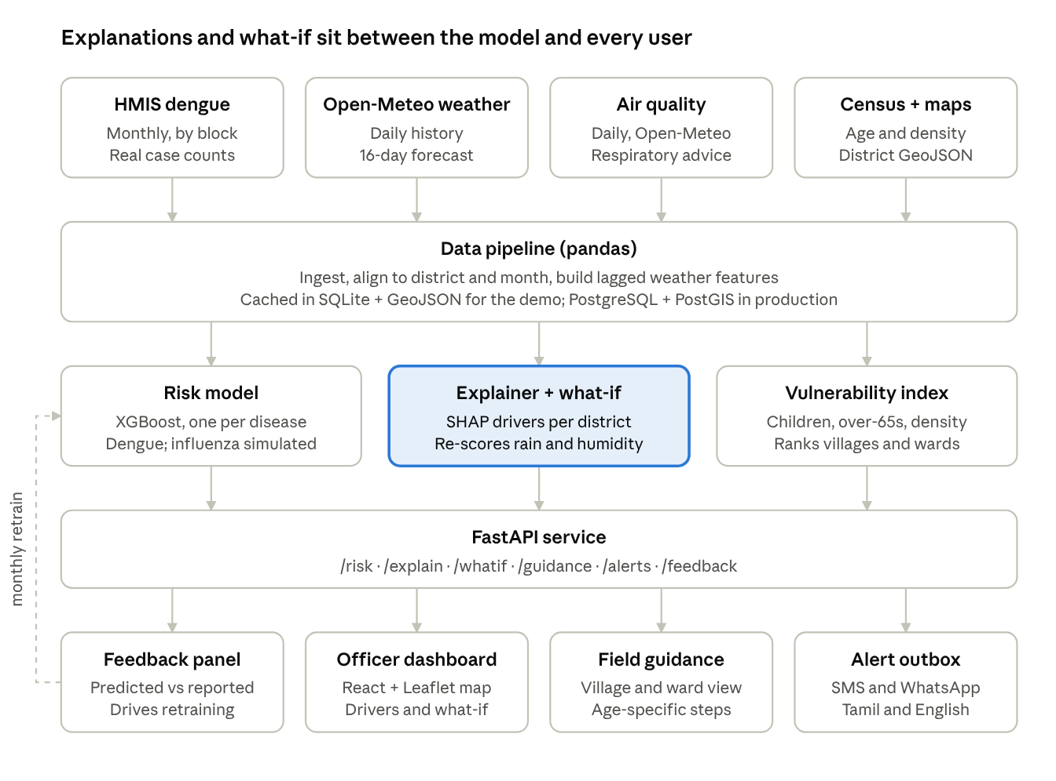
ClimaGuard prototype architecture · 5 layers
Data flows top to bottom. The dashed line is the feedback loop: outlooks are compared with reported cases and the model is retrained monthly.

6.2 Officer dashboard (wireframe)
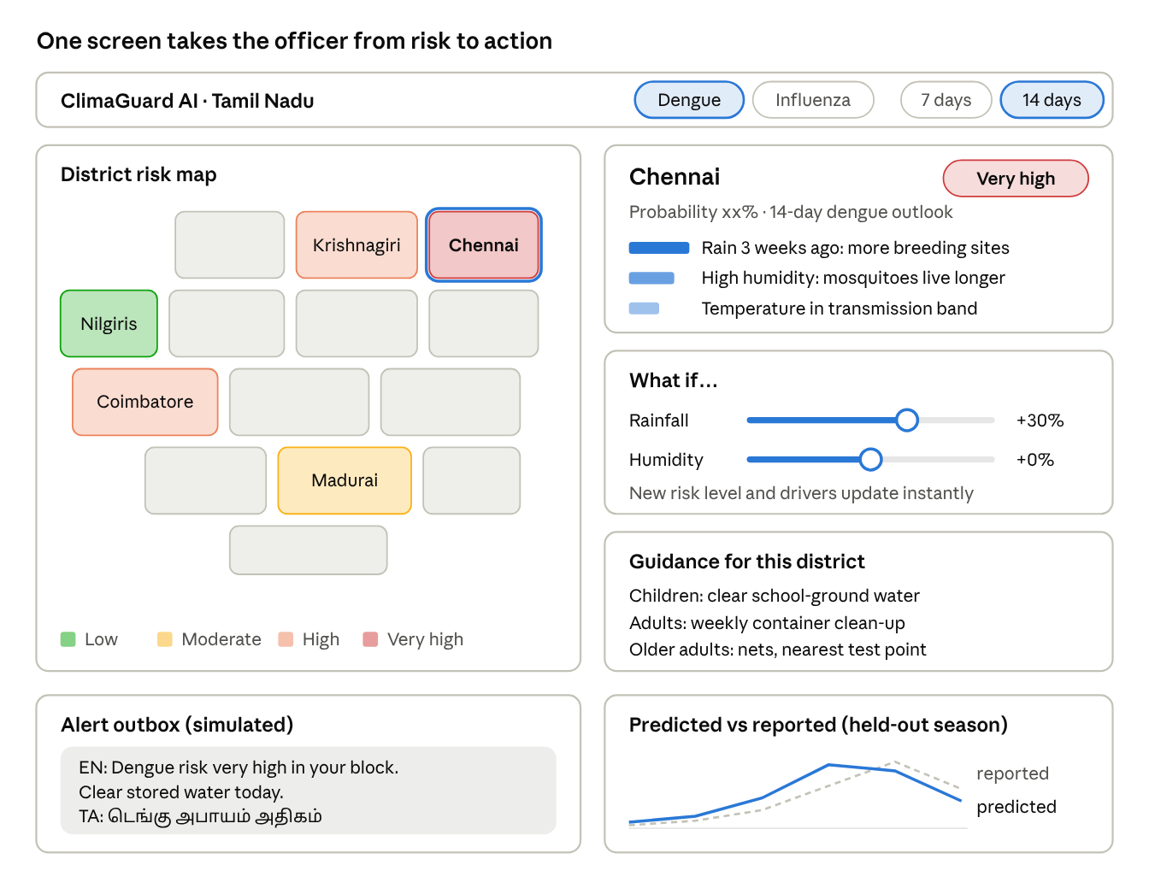
Wireframe · sample content for illustration, not real data
The officer picks a district on the map, reads its drivers, tests a wetter forecast, then sends guidance through the outbox. The feedback panel shows how earlier outlooks compared with reported cases.

6.3 Screens in the prototype
- State risk map – every district coloured by risk level, 7/14 day toggle, disease switch, "needs attention" list.
- District detail – risk level and probability, top three drivers as cards, 12-month trend.
- What-if simulator – rainfall and humidity sliders with the new level shown beside the current one.
- Micro-zone view – villages and wards ranked by priority, with guidance for children, adults and older people.
- Alert outbox – the exact SMS/WhatsApp messages each audience would receive, in Tamil and English.
- Feedback panel – predicted risk against reported cases for the held-out season.

6.4 Real-data proof
A chart of weekly rainfall against monthly dengue cases for Chennai, with the lag between them marked, will be placed here once the HMIS and Open-Meteo files are downloaded.

6.5 Build plan for the build round
Role | Hours 0–12 | Hours 12–24 | Hours 24–36
ML / data lead | Clean HMIS and weather data, build features | Train XGBoost and baselines, run backtest | SHAP cards, what-if endpoint, metrics
Backend and pipeline | FastAPI skeleton, SQLite and GeoJSON layer | Risk, explanation and alert endpoints | Alert rules, Tamil/English templates
Frontend and map | React app, Leaflet district map | District detail, sliders, guidance cards | Outbox and feedback panel, polish
Research, docs and pitch | Guidance text, vulnerability data | Demo script for five districts | Slides, rehearsal, final checks

Sources
- South India dominates India's dengue burden – The South First
- TN tops dengue cases in 2025 – DT Next
- TN declares red alert in three districts – DT Next
- TN Health Dept on high alert – The News Minute
- TN dengue surge and IHIP reporting – Elets eHealth
- Rising temperatures, rising dengue – Springer Nature
- Kerala gets a dengue early-warning model – The South First
- AI model predicts dengue outbreaks two months ahead – Gavi
- HMIS sub-district monthly data – Dataful

